Lab No: 01
Lab Name: DDA Line Drawing Algorithm
Program:
#include <graphics.h>
#include <stdio.h>
#include <math.h>
int main( )
{
float x,y,x1,y1,x2,y2,dx,dy,pixel;
int i,gd,gm;

printf("Enter the value of x1 : ");
scanf("%f",&x1);
printf("Enter the value of y1 : ");
scanf("%f",&y1);
printf("Enter the value of x2 : ");
scanf("%f",&x2);
printf("Enter the value of y2 : ");
scanf("%f",&y2);
printf("The Line is\n");
detectgraph(&gd,&gm);
initgraph(&gd,&gm,"");

dx=abs(x2-x1);
dy=abs(y2-y1);

if(dx>=dy)
pixel=dx;
else
pixel=dy;

dx=dx/pixel;
dy=dy/pixel;

x=x1;
y=y1;
i=1;

while(i<=pixel)
{
putpixel(x,y,WHITE);
x=x+dx;
y=y+dy;
i=i+1;
delay(30);
}

getch();
}
Sample Input:
Enter the value of x1 : 100
Enter the value of y1 : 100
Enter the value of x2 : 300
Enter the value of y2 : 200
Output:
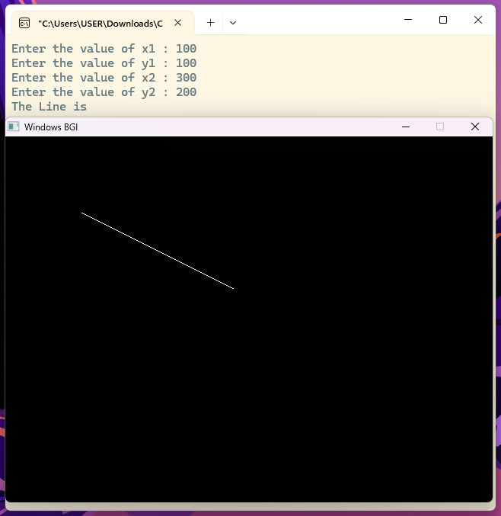

Lab No: 02
Lab Name: Bresenham Line Drawing Algorithm
Program:
#include <graphics.h>
#include <stdio.h>
#include <math.h>

int main()
{
int x,y,x1,y1,x2,y2,dx,dy,p,gd,gm;

printf("Enter the value of x1 : ");
scanf("%d",&x1);
printf("Enter the value of y1 : ");
scanf("%d",&y1);
printf("Enter the value of x2 : ");
scanf("%d",&x2);
printf("Enter the value of y2 : ");
scanf("%d",&y2);

detectgraph( &gd,&gm);
initgraph(&gd,&gm,"");

dx = abs(x2 - x1);
dy = abs(y2 - y1);

x = x1;
y = y1;

p = 2*dy - dx;

while(x <= x2)
{
putpixel(x,y,WHITE);

if(p < 0)
{
x = x + 1;
p = p + 2*dy;
}
else
{
x = x + 1;
y = y + 1;
p = p + 2*dy - 2*dx;
}
delay(30);
}
getch();
closegraph();
return 0;
}
Sample Input:
Enter the value of x1 : 100
Enter the value of y1 : 100
Enter the value of x2 : 300
Enter the value of y2 : 200
Output:
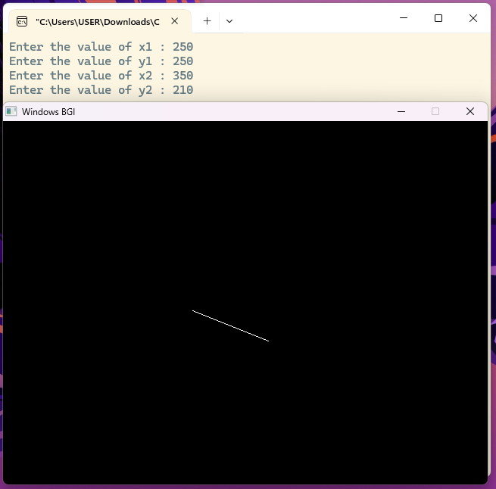

Lab No: 03
Lab Name: Bresenham Circle Drawing Algorithm
Program:
#include <graphics.h>
#include <stdio.h>

int main()
{
int xc,yc,r;
int x,y,p;
int gd,gm;

printf("Enter center xc : ");
scanf("%d",&xc);
printf("Enter center yc : ");
scanf("%d",&yc);
printf("Enter radius r : ");
scanf("%d",&r);

detectgraph(&gd,&gm);
initgraph(&gd,&gm,"");

x = 0;
y = r;
p = 3 - 2*r;

while(x <= y)
{
putpixel(xc+x,yc+y,WHITE);
putpixel(xc-x,yc+y,WHITE);
putpixel(xc+x,yc-y,WHITE);
putpixel(xc-x,yc-y,WHITE);

putpixel(xc+y,yc+x,WHITE);
putpixel(xc-y,yc+x,WHITE);
putpixel(xc+y,yc-x,WHITE);
putpixel(xc-y,yc-x,WHITE);

if(p < 0)
{
p = p + 4*x + 6;
}
else
{
p = p + 4*(x - y) + 10;
y = y - 1;
}

x = x + 1;
delay(30);
}

getch();
closegraph();
return 0;
}
Sample Input:
Enter center xc : 200
Enter center yc : 200
Enter radius r : 100
Output:
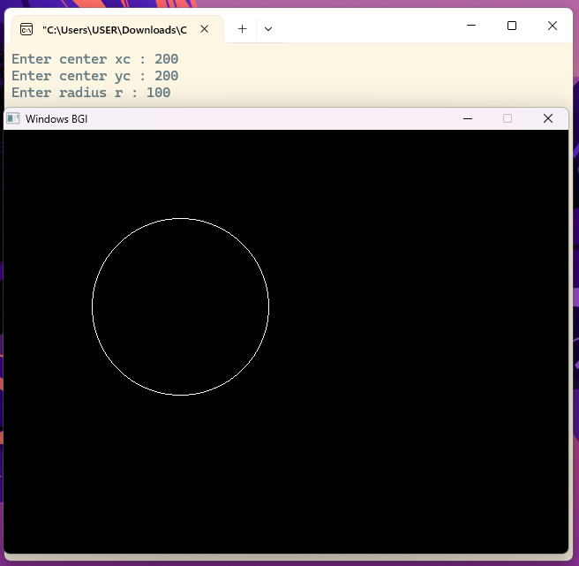
Lab No: 04
Lab Name: Midpoint Circle Drawing Algorithm
Program:
#include <graphics.h>
#include <stdio.h>

int main()
{
int xc,yc,r;
int x,y,p;
int gd,gm;

printf("Enter center xc : ");
scanf("%d",&xc);
printf("Enter center yc : ");
scanf("%d",&yc);
printf("Enter radius r : ");
scanf("%d",&r);

detectgraph(&gd,&gm);
initgraph(&gd,&gm,"");

x = 0;
y = r;
p = 1 - r;

while(x <= y)
{
putpixel(xc+x,yc+y,WHITE);
putpixel(xc-x,yc+y,WHITE);
putpixel(xc+x,yc-y,WHITE);
putpixel(xc-x,yc-y,WHITE);

putpixel(xc+y,yc+x,WHITE);
putpixel(xc-y,yc+x,WHITE);
putpixel(xc+y,yc-x,WHITE);
putpixel(xc-y,yc-x,WHITE);

if(p < 0)
{
p = p + 2*x + 3;
}
else
{
p = p + 2*(x - y) + 5;
y = y - 1;
}

x = x + 1;
delay(30);
}

getch();
closegraph();
return 0;
}
Sample Input:
Enter center xc : 200
Enter center yc : 200
Enter radius r : 100
Output:
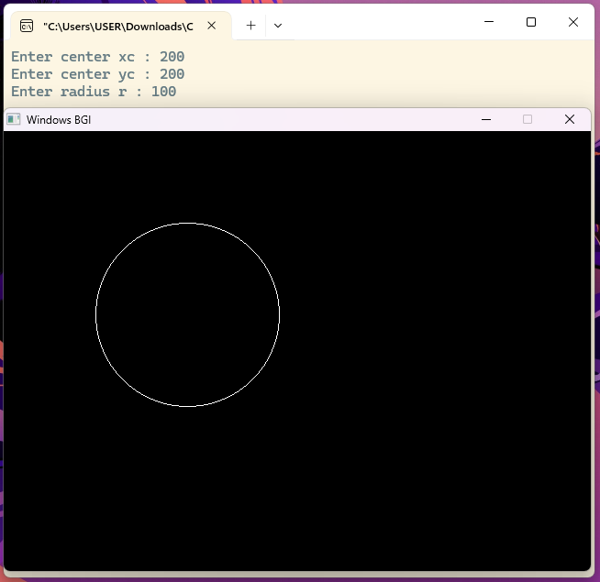
Lab No: 05
Lab Name: Midpoint Ellipse Drawing Algorithm
Program:
#include <graphics.h>
#include <stdio.h>

int main()
{
int xc,yc;
int rx,ry;
int x,y;
long p1,p2;
int gd,gm;
printf("Enter center xc : ");
scanf("%d",&xc);
printf("Enter center yc : ");
scanf("%d",&yc);
printf("Enter x-radius rx : ");
scanf("%d",&rx);
printf("Enter y-radius ry : ");
scanf("%d",&ry);

detectgraph(&gd,&gm);
initgraph(&gd,&gm,"");

x = 0;
y = ry;

p1 = ry*ry - rx*rx*ry + (rx*rx)/4;

while(2*ry*ry*x <= 2*rx*rx*y)
{
putpixel(xc+x,yc+y,WHITE);
putpixel(xc-x,yc+y,WHITE);
putpixel(xc+x,yc-y,WHITE);
putpixel(xc-x,yc-y,WHITE);

if(p1 < 0)
{
p1 = p1 + 2*ry*ry*x + ry*ry;
}
else
{
p1 = p1 + 2*ry*ry*x - 2*rx*rx*y + ry*ry;
y = y - 1;
}
x = x + 1;
delay(20);
}

p2 = ry*ry*(x+0.5)*(x+0.5) + rx*rx*(y-1)*(y-1) - rx*rx*ry*ry;

while(y >= 0)
{
putpixel(xc+x,yc+y,WHITE);
putpixel(xc-x,yc+y,WHITE);
putpixel(xc+x,yc-y,WHITE);
putpixel(xc-x,yc-y,WHITE);

if(p2 > 0)
{
p2 = p2 - 2*rx*rx*y + rx*rx;
}
else
{
p2 = p2 + 2*ry*ry*x - 2*rx*rx*y + rx*rx;
x = x + 1;
}
y = y - 1;
delay(20);
}

getch();
closegraph();
return 0;
}
Sample Input:
Enter center xc : 250
Enter center yc : 250
Enter x-radius rx : 150
Enter y-radius ry : 80
Output:
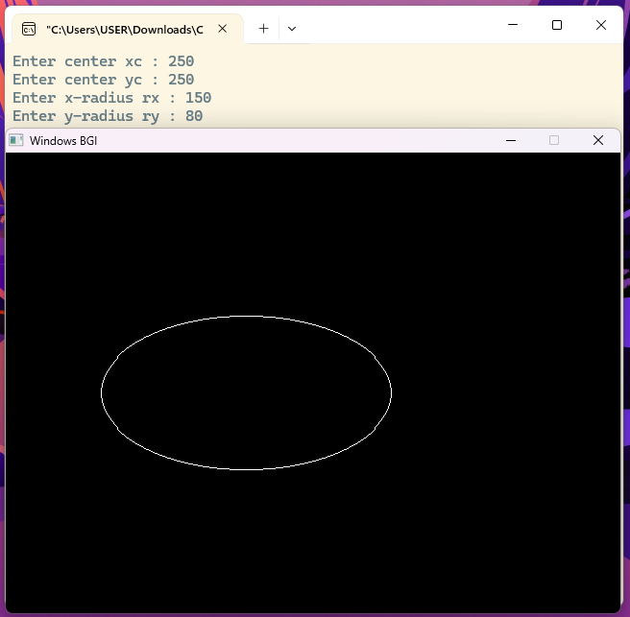

Lab No: 06
Lab Name: Liang–Barsky Line Clipping Algorithm
Program:
#include<stdio.h>
#include<graphics.h>

int main()
{
int gd=DETECT, gm;
int x1, y1, x2, y2;
int xmin, ymin, xmax, ymax;
int xx1, yy1, xx2, yy2;
int dx, dy, i;
int p[4], q[4];
float t[4], t1, t2;
printf("Enter lower coordinates of window: ");
scanf("%d %d", &xmin, &ymin);
printf("Enter upper coordinates of window: ");
scanf("%d %d", &xmax, &ymax);
printf("Enter x1 y1: ");
scanf("%d %d", &x1, &y1);
printf("Enter x2 y2: ");
scanf("%d %d", &x2, &y2);

initgraph(&gd,&gm," ");

setcolor(RED);
rectangle(xmin, ymin, xmax, ymax);
line(x1, y1, x2, y2);

dx = x2 - x1;
dy = y2 - y1;

p[0] = -dx; q[0] = x1 - xmin;
p[1] = dx; q[1] = xmax - x1;
p[2] = -dy; q[2] = y1 - ymin;
p[3] = dy; q[3] = ymax - y1;

for(i = 0; i < 4; i++)
{
if(p[i] != 0)
t[i] = (float)q[i] / p[i];
else if(p[i] == 0 && q[i] < 0)
{
printf("Line completely outside the window\n");
getch();
closegraph();
return 0;
}
else
t[i] = (i < 2) ? 0.0 : 1.0; // partially inside
}

t1 = (t[0] > t[2]) ? t[0] : t[2];
t2 = (t[1] < t[3]) ? t[1] : t[3];

if(t1 < t2)
{
xx1 = x1 + t1*dx;
yy1 = y1 + t1*dy;
xx2 = x1 + t2*dx;
yy2 = y1 + t2*dy;
printf("Line after clipping drawn in WHITE\n");
setcolor(WHITE);
line(xx1, yy1, xx2, yy2);
}
else
{
printf("Line lies completely outside the window\n");
}

getch();
closegraph();
return 0;
}
Sample Input:
Enter lower coordinates of window: 100 100
Enter upper coordinates of window: 300 300
Enter x1 y1: 50 150
Enter x2 y2: 350 250
Output:
